STUDENT MANAGEMENT SYSTEM

Technical Test Submission

Developed using
React.js | Node.js | Express.js | MongoDB

Submitted by:
Yash Talaviya

October 2026

Project Overview
I developed this Student Management System as part of the technical test. The application provides a simple way to manage student records through a web interface.
The system includes a login screen and a student management dashboard. After logging in, the user can add, view, edit and delete student records.
React.js is used for the frontend, Node.js and Express.js are used for the backend APIs, and MongoDB is used to store the data.

GitHub Repository:
1 Login Page:
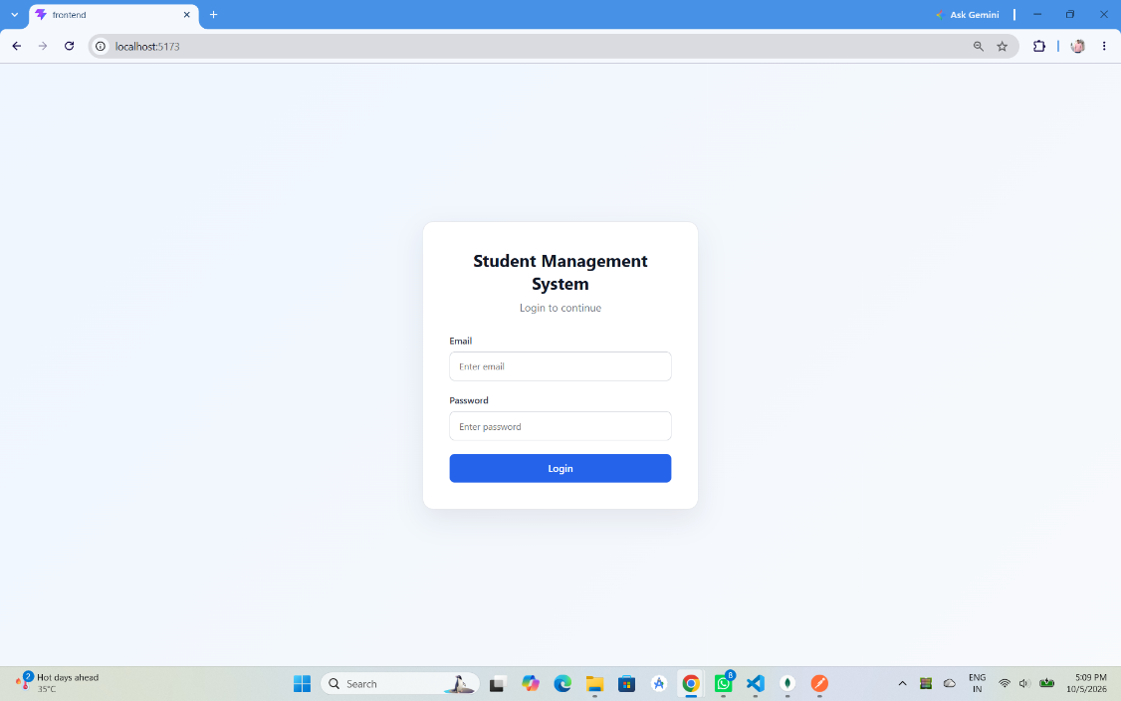
2 Test with Wrong Password:
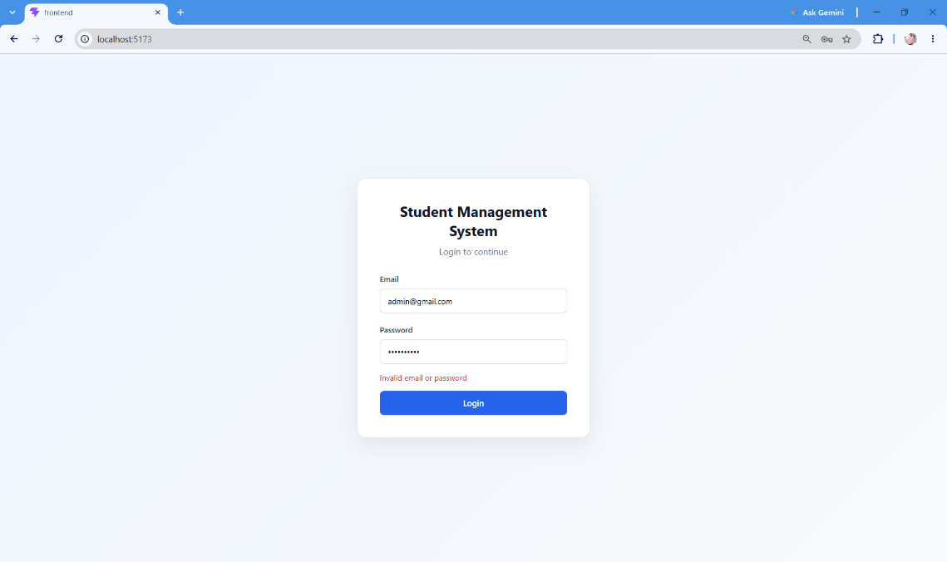
3 Dashboard:
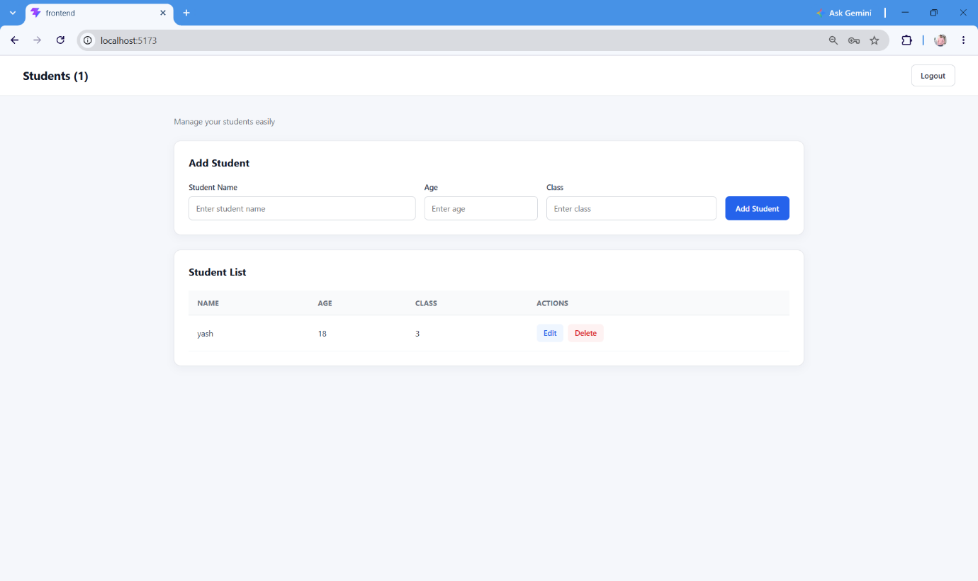
4 Add Student:
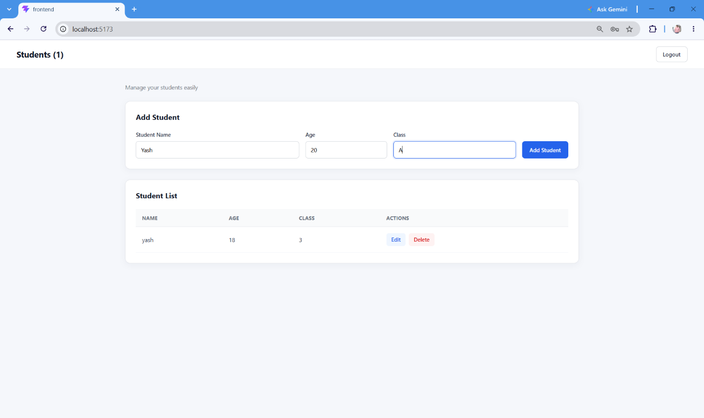

5 Successfully Added:
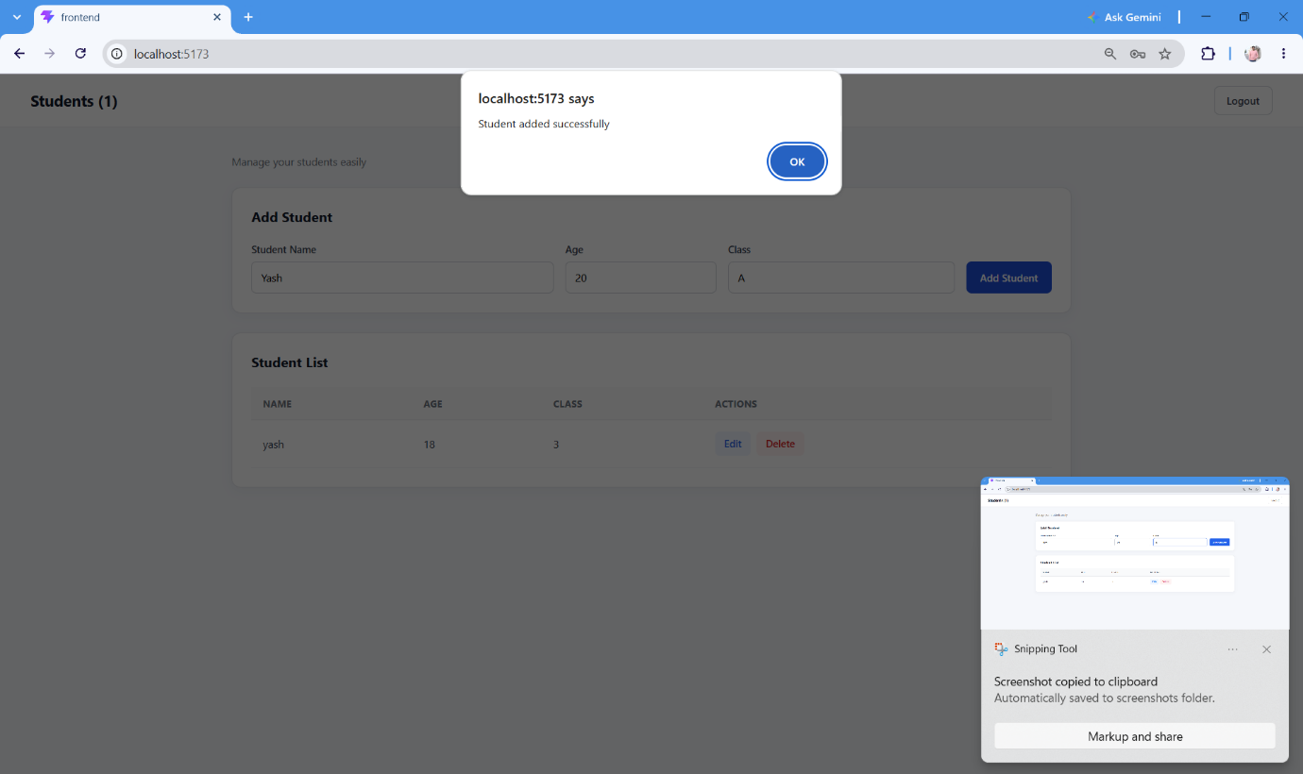

6 Addedd Successfully:
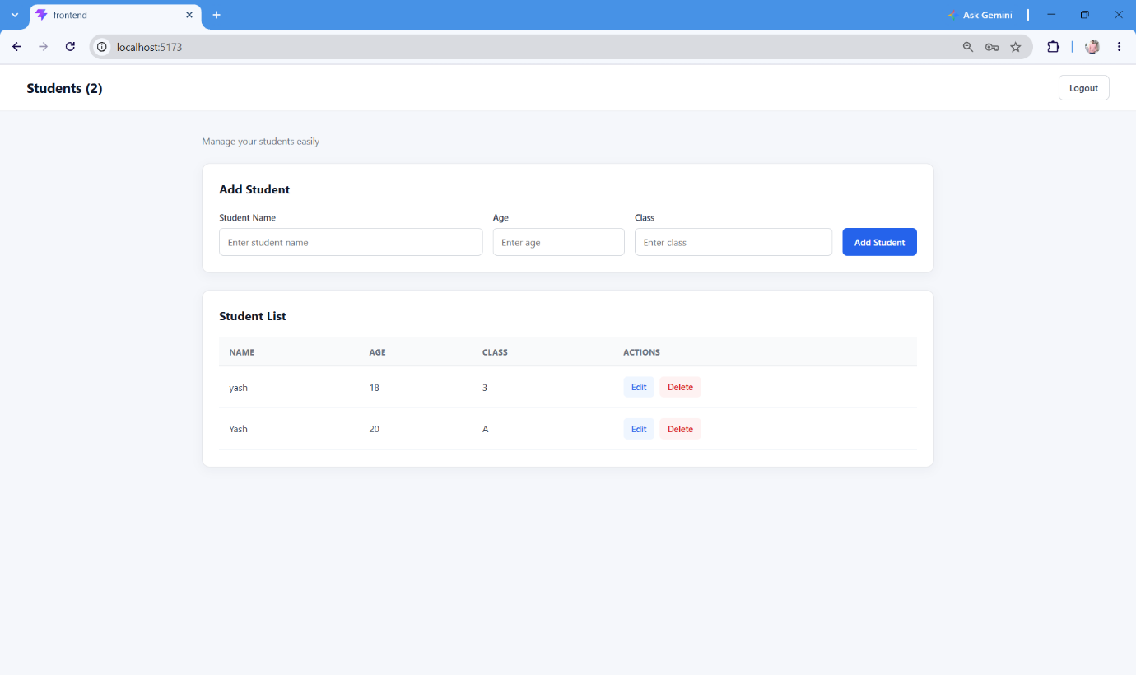

7 Update Student:
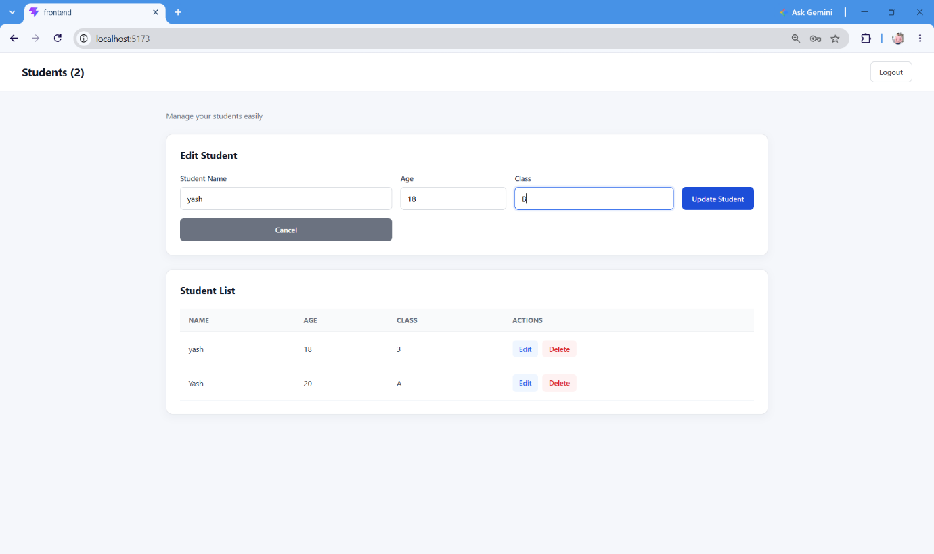

8 Updated Sucessfully:
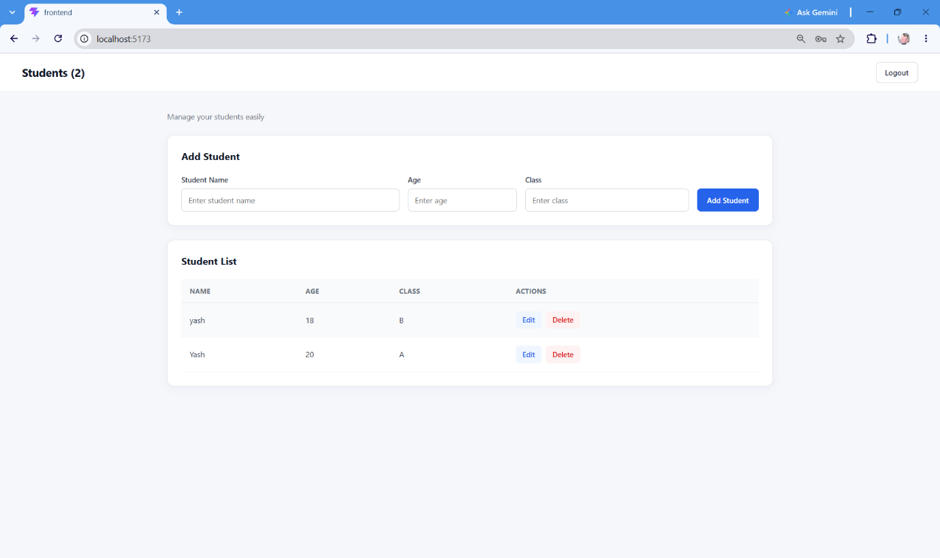

9 Delete One Student:
